BBC Maximo 7.5 P2P Redesign

Andy Timmins – 18/09/2014

**Document History**

|  |  |  |  |
| --- | --- | --- | --- |
| **Author** | **Date** | **Revision** | **Comments** |
| Andy Timmins | 18/09/2014 | 0.1 | Initial Draft |
|  |  |  |  |
|  |  |  |  |

Contents

Changes to Maximo Workflows 4

PO Approval Workflows 4

MAINPOWF 4

# 

# Changes to Maximo Workflows

## PO Approval Workflows

### MAINPOWF

**Business Process:**



**Maximo Workflow Designer View:**

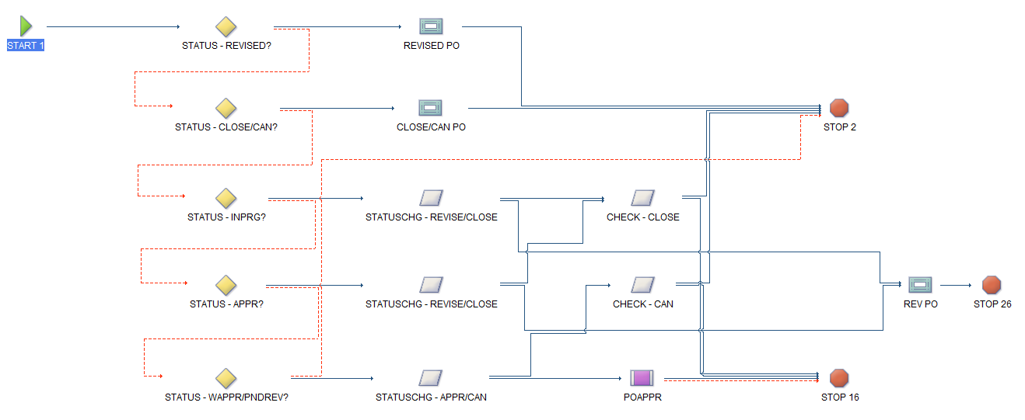

**Maximo Workflow Definition:**

|  |  |  |  |  |  |  |  |  |
| --- | --- | --- | --- | --- | --- | --- | --- | --- |
| Node | Description | Node Type | Condition Details | Message Title | Message Body | Sub Process | Action (Neg/Pos) | Next Node (Neg/Pos) |
| START 1 | START 1 | START |  |  |  |  |  | STATUS - REVISED? |
| STATUS - REVISED? | Status is Revised? | CONDITION | status = 'REVISD' |  |  |  |  | STATUS - CLOSE/CAN?  REVISED PO |
| STATUS - CLOSE/CAN? | Is Status CLOSE or CAN | CONDITION | status in ('CLOSE','CAN') |  |  |  |  | STATUS - INPRG?  CLOSE/CAN PO |
| STATUS - INPRG? | Check if Status is INPRG | CONDITION | status = 'INPRG' |  |  |  |  | STATUS - APPR?  STATUSCHG - REVISE/CLOSE |
| STATUS - APPR? | Is Status APPR? | CONDITION | status in ('APPR') |  |  |  |  | STATUS - WAPPR/PNDREV?  STATUSCHG - REVISE/CLOSE |
| STATUS - WAPPR/PNDREV? | Is Status WAPPR/PNDREV | CONDITION | status in ('WAPPR','PNDREV') |  |  |  | IRVNULLQTY | STOP 2  STATUSCHG - APPR/CAN |
| REVISED PO | REVISED PO | INTERACTION |  | Error - Status REVISD. | The status is REVISD, please process the latest revision. |  |  | STOP 2 |
| CLOSE/CAN PO | Cannot Process CLOSE/CAN PO | INTERACTION |  | Error - Status CLOSE/CAN | Cannot Process PO at Status CLOSE/CAN |  |  | STOP 2 |
| STATUSCHG - REVISE/CLOSE | Change Status to FINCOM or CLOSE status? | INPUT |  |  |  |  |  | CHECK - CLOSE |
| STATUSCHG - REVISE/CLOSE | Change Status to FINCOM or CLOSE status? | INPUT |  |  |  |  |  | REV PO |
| STATUSCHG - REVISE/CLOSE | Change Status of PO. | INPUT |  |  |  |  |  | CHECK - CLOSE |
| STATUSCHG - REVISE/CLOSE | Change Status of PO. | INPUT |  |  |  |  |  | REV PO |
| STATUSCHG - APPR/CAN | Is PO to be cancelled or sent for approval? | INPUT |  |  |  |  |  | CHECK - CAN |
| STATUSCHG - APPR/CAN | Is PO to be cancelled or sent for approval? | INPUT |  |  |  |  |  | POAPPR |
| CHECK - CLOSE | Are you Sure you want to CLOSE PO? | INPUT |  |  |  |  | PO CLOSE | STOP 2 |
| CHECK - CLOSE | Are you Sure you want to CLOSE PO? | INPUT |  |  |  |  |  | STOP 16 |
| CHECK - CAN | Are you sure you want to change status to CAN? | INPUT |  |  |  |  | PO CANCEL | STOP 2 |
| CHECK - CAN | Are you sure you want to change status to CAN? | INPUT |  |  |  |  |  | STOP 16 |
| POAPPR | HALA P2P PO Approval | SUBPROCESS |  |  |  | POAPPR |  | STOP 16  STOP 16 |
| STOP 2 | STOP 2 | STOP |  |  |  |  |  |  |
| STOP 16 | STOP 16 | STOP |  |  |  |  |  |  |
| REV PO | Revise PO | INTERACTION |  | Revise PO | To revise the PO choose 'Revise PO' from the select action menu. |  |  | STOP 26 |
| STOP 26 | STOP 26 | STOP |  |  |  |  |  |  |

### POAPPR

**Business Process:**